(Approx. 901 words)

360 Video Cameras
By Len Nasman, Editor, Bristol Village Computer Club, OH
May 2017 issue, BVCC Newsletter
www.bvrs.org
bvclub (at) bvrs.org

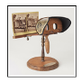
Ever since the early days of photography designers have been working on ways to show the world in three dimensions. At one point, many households owned a stereoscope that simulated 3D scenes.

The trick used with the stereoscope was to take two pictures at the same time with two camera lenses that were spaced about the same distance apart as the average human eyes. Then, if you looked at each picture with a different eye, your brain would merge the images into a kind of three-dimensional view.

BTW, did you know that if you only have one eye, you do not have
depth perception? Want to test the concept? Point your two index fingers
at each other and, holding them at arm’s length and with one eye closed,
make the fingers touch.

Photographers roamed the world taking stereoscope pictures to sell. The pictures gave people a chance to see sights beyond their limited locale.

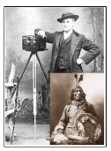
Here is a picture of my third cousin John Anderson with his stereoscope camera. He had a trading post near the Rosebud Sioux reservation and took many classic pictures of Native Americans. You might remember someone in your family who, back in the old days, had a collection of the stereoscope pictures.

The same two-picture 3D technique was used by the ViewMaster. Pairs of pictures were mounted on a circular holder, and as you clicked a lever the next pair of pictures were rotated into place. The ViewMaster made it easy to focus each eye on a different picture, thus providing the 3D effect.
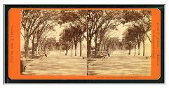

The stereoscope and the ViewMaster required special cameras to create the pictures, and it was not very common for the average person to make their own 3-D picture pairs.

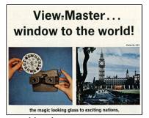
Three D still photography has been around for a long time. Inventors were making stereoscope devices in the mid 1800’s. Creating 3D movies, was another story. Inventors struggled with using the two-eye trick in movies.

One frequently used technique was to have the viewer wear glasses with two different colored lenses. Pictures were made with two different colored filters… red and blue.
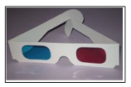

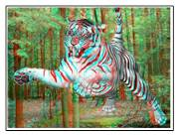
When you looked at the pictures without special glasses, you would see fuzzy red and blue versions of the image. But, through the colored lenses, your brain could merge the images and make them appear to have depth. If you look at the tiger picture with red-blue glasses, the tiger appears to be jumping out of the page.

A similar trick was to replace the red and blue images with polarized light. The special glasses would have the lenses alternate the polarization to again fool your brain into seeing 3D.

There have been many attempts to market 3D movies and 3D television sets. Although there have been a few hits, popularity has declined. One problem is that forcing your brain to merge two different images from your eyes is a bother. Some folks soon get headaches, and the effect can be lost when a persons’ pupil- to-pupil distance does not match the separation distance of the two cameras.

360 Photos
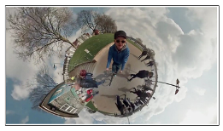
The processing power of computer chips together with very sophisticated image display software has created a whole new approach to creating 360 degree views of the world. If you have used Google Street views and panned around and up and down on a view, you are familiar with 360 still photos.

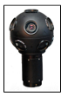
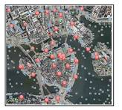
Pictures are taken using a camera with a fish eye lens. The picture will, of course, look distorted when viewed normally. However, through some magic mathematical image processing, a normal appearing image can be viewed, and the direction point of the image can be manipulated by the user. New cameras have gone beyond a single fish eye lens. The cameras used to take Google e Street Views have 9 different lenses. The images are stitched together with some very sophisticated software.

Google Earth Pro allows people to upload 360 photos and pin them to Google Earth locations. For example, a Google Earth Pro view of Stockholm shows markers for both regular and 360 view images. The red markers in the Google Earth Pro view of Stockholm are links to pictures taken with 360 cameras.

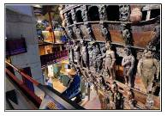
Here is a 360 view of the historic ship Vasa found in Stockholm. When you are viewing this in Google Earth you can use your mouse to change your viewing direction.
The next step in 360 visualization technology is to apply the principles to full motion video.

Download the free Google Earth Pro software.
https://www.google.com/earth/download/gep/agr ee.html

360 Videos

The next step in 360 visualization technology is to apply the principles to full motion video.

YouTube has a whole section devoted to 360 videos.
https://www.youtube.com/channel/UCzuqhhs6NWbgTzMuM09WKDQ

360 Cameras
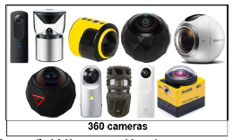
The early 360 cameras were either experimental or expensive professional devices, like the Google cameras. Now, however, the technology has followed the familiar path of better quality and lower prices.

You can find 360 cameras with various resolutions and features for prices from under $200 to many thousands of dollars. There are versions for underwater, versions that look like cell phones, versions for mounting on vehicles, versions designed for security systems, and very portable versions that you can wear on your hat.

For viewing, there are virtual reality glasses available so that you can view your 360 pictures anywhere.

